Statement of Work for

MedTalk

Presented to David Aguilar / Gil Bender

By SETA International

bruce@seta-international.com

The above parties agree that the information in this estimate shall not be disclosed to any outside party and shall not be duplicated, used or disclosed in whole or in part for any purpose other than to evaluate the estimate. This estimate is valid until May 31, 2011, after which date SETA International, LLC retains the right to make revisions. This restriction does not limit the right of each party to use information contained in this estimate if it was obtained from another source without restriction

Table of Contents

1. Executive Summary 1

1.1 Project Overview 1

1.2 Project Scope 3

1.3 Assumptions 5

1.4 Our Approach to Meet Your Objectives 6

1.5 Project Team 7

1.6 Project Cost 8

1.7 Payment Terms & Conditions 9

2. Project Management 10

3. Solution Overview 11

3.1 System Overview 11

3.2 System Architecture 12

Acceptance and authorization 14

4. Appendix 15

4.1 Task Breakdown Structure 15

4.2 Misc. Information 15

# **Executive Summary**

## Project Overview

**Medtalk.com** will change the way physicians, nurses and other healthcare providers interact and take care of patients. Current methods of communication in medicine, including telephones and pagers, are slow, time consuming and error prone. Communication through medtalk will be easier, faster, more accurate and effective between healthcare workers in the hospital, office and anywhere patient care is involved.

Medtalk is a web based platform that is comprised of a working network of healthcare providers including, but not limited to, physicians and nurses. The core concept of medtalk is a messaging tool that can be accessed through the medtalk website via desktop, laptop or mobile device. Through medtalk’s network of members and its messaging system, a physician can select another physician and send a real- time, instant, date and time stamped, hippa compliant message that can be read and replied to in similar fashion. Secondly, a hospital nurse, or other hospital staff member, can communicate with a medtalk physician by sending a real-time message via the medtalk messaging system to doctors, who then can respond in a timely, accurate and industry compliant fashion. This will help eliminate medication errors, or other communication errors, and will accurately document every interaction between hospital staff and physicians.

Two use case examples will illustrate the benefits of medtalk and how communication will evolve and improve in medicine while lowering healthcare costs and liability. Currently direct communication between physicians does not occur because of the cumbersome nature involved with finding, calling, and waiting for physicians on the telephone. Further, hospital nurses can only communicate with physicians by telephone despite this slow, ineffective and non documented method.

**Use Case #1:** A physician hospitalist, a doctor who is in charge of the care of hospitalized patients, needs to inform the primary doctor, medical specialists and home health nurses about the hospital course and discharge plans for their hospitalized patient. A phone call to each healthcare worker is needed. The time involved renders this method virtually impossible and therefore, it is not done. With medtalk, the hospitalist logs onto medtalk, finds the providers involved in the patients care, sends a quick real-time message like, ” Mrs. Jones is going home today, she had a negative mri and eeg but her blood pressure medication was changed to Toprol XL 50 mg q day. She needs follow up in 1 week. Thanks.” The receiving medtalk members receive the message on their medtalk mobile app, pad or desktop instantly, and can reply to the sender and the other providers. Medtalk replaces the slow, time wasting telephone process and even slower paper mail. Also, medtalk ensures accurate, documented communication.

**Use Case #2:** a surgical floor nurse needs to notify the patient’s surgeon of a blood test result that may require an alteration in the patient’s care such as a medication change. Currently, if the surgeon isn’t standing next to her, she has to call his office or page him, wait on the phone, interrupt his current work and relay the message. This can take 20 to 30 minutes or more of the nurse’s time. Then, the surgeon replies with a “verbal order” that can be easily misinterpreted and incorrectly transcribed by the nurse, leading to a costly or deadly error. With Medtalk, the nurse finds the Medtalk surgeon, sends the encrypted message via medtalk and receives an automatic confirmation that the surgeon received the hippa compliant message. The surgeon, on his time, processes the information and responds. For example, “Please give Mr. Smith heparin 5000 units SQ times 1.” The message and return order is fast, compliant, time stamped and accurate.

As demonstrated by these cases, physicians’ and nurses’ time will be saved, patient care will be better and safer, medication errors will decrease, physician and hospital malpractice cases will decrease and communication will be more precise and time stamped. With these and many other benefits, medtalk will improve healthcare overall.

## Project Scope

Medtalk will need a web based software program and website that is fully functional for mobile devices. The program will be easily downloadable for use on desktops, laptops and mobile devices using the iphone, droid, blackberry and windows based operating systems at the minimum. Medtalk will be loadable and functional on hospital based and other facility systems and in all cases will be extremely user friendly, fast, simple and professional. It will be internationally adaptable and use mobile enablement allowing for global, simple and effective access.

*Detailed breakdown of each of the task/function below is outlined in Appendix A.*

|  |  |
| --- | --- |
| **Task / Function** | **Item Description** |
| **Discovery** | |
| Discovery | * Requirements Analysis * Technical Evaluation |
| **Wireframes / Graphical Design** | |
| Wireframes | * Wireframe creation * Client modifications and assessments |
| Creative Design | * Creative Design * Client Discussion and Modifications |
| **Prototype Development** | |
| Prototype | * Flash Presentation |
| **Application Development (Web Application)** | |
| Platform Development | * Hippa Compliace * Instant/Real Time (text, email) * Date/Time Stamp * Voice to Text Capabilities * External Database Integration * Internationalization |
| MedTalk Frontend Application | * MedTalk Introduction * MedTalk Message * MedTalk Members * Business Talk |
| MedTalk Backend Application | * Content Management System * Message System * Users Management * Photos Management * Advertise Management * Capture Users/Feedback * Custom Medical Dictionary Management |
| **Application Development (Mobile Application)** | |
| Mobile Development | * Web-based software program that is fully functional for mobile devices * iPhone MedTalk Application * Droid MedTalk Application * Blackberry MedTalk Application |
| **Deployment** | |
| Deployment | * Deployment |
| **Maintenance & Support** | |
| Maintenance & Support | * Post Deployment Maintenance & Support |

## Assumptions

1. HIPPA Compliant (at least)
   1. Encrypted
   2. Back up and recoverable
   3. Only accessible by authorized personnel
   4. Tamper proof cannot be altered
   5. Stored and archived in encrypted manner
   6. When not needed can be disposed of properly and permanently
2. Hospital compliant
3. Simple and secure retrieval system so that hospitals and members can access stored or archived messages. If necessary, this retrieval system needs to be more than what is accomplished by hosting servers.
4. Medical legal approval
5. Instant/Real time (like text or email)
6. Date and time “stamped” very important function of medtalk
7. Photos if simple and easy. If not perhaps build in but not roll out until later.
8. Text has no restriction of character number
9. Voice to text capable
10. Message recall or reminder capability (e.g., physician receives patient information that he would like to recall later, hours or days). Only if easy and workable in all apps including mobile app.
11. *If hippa allowable*, messages can be personally archived and printed.
12. Depending on screen size and device, a hippa compliance regulatory note will be needed similar to what is used at the end of emails. For example, “this medtalk message contains confidential information…as defined by the HIPPA privacy rule…please notify sender…etc…
13. The work to be developed under this Statement of Work (SOW) is described under section 1.1. The scope constitutes Work Product as defined in the Professional Services Agreement below in Section 3. Any changes to this SOW (whether by introducing new functions, features or increasing time) will be communicated to the Client for Approval prior to executing. All Client requests to change and / or introduce new functions or features into this SOW shall be handled in accordance with SETA’s Change Order Process.
14. Outside of the additional feature sets outlined in the scope of services above, any net new feature requests or enhancements will be executed via block hours.
15. A detailed project schedule including milestones and task activities for SETA’s scope of services will be established shortly after project approval.
16. Creative designs will include our logo and brand design including design for paper products
17. Required legal and professional disclaimers that we provide will be included were appropriate throughout the platform and at the end of medtalk messages as needed.
18. The medtalk message system will have a reminder tool that will allow a physician or other medtalk member to set a  reminder date that brings up a particular message received but 1-7 days later (for example).
19. We will verify professional status, i.e. physicians, nurse, etc. where possible in all instances.
20. Medtalk will have a "medtalk language"  database.
21. Gil Bender and David Aguiliar’s personal email to have medtalk logo/link to website or mobile app.

## Our Approach to Meet Your Objectives

1. Work closely with the client to obtain and document all detailed requirements and expectations from the client.
2. Leverage best practices during the entire development and quality assurance lifecycle for the new web application.
3. Establish a support model to provide adequate support to all end users of the new web application.
4. Establish a project management office to ensure that the schedule, quality and end deliverable meets client expectations.
5. Establish multiple check/validation points in every phase of the development cycle to eliminate scope creep while meeting client expectations.
6. Assemble a team of highly qualified software engineers and project managers to successfully complete the project. (Section 1.5)

## Project Team

**Project Stakeholders**

|  |  |  |  |
| --- | --- | --- | --- |
| **Name** | **Title** | **Role & Responsibility** | **Contact information** |
| Dr. Dave Aguilar | Partner | **MedTalk**  Focal Point | **Voice:**  **Fax:**  **Email:** dr.a@tcpeds.com |
| Dr. Gil Bender | Partner | **MedTalk**  Focal Point | **Voice:**  **Fax:**  **Email:** gilbender@aol.com |
| Bruce Watanabe | Managing Partner | **SETA International (North America)** Focal Point | **Voice:** (949) 887-6884  **Fax:** (949) 480-9474  **Email:** bruce@seta-international.com |
| Sean McEvoy | Managing Partner | **SETA International (North America)** Focal Point | **Voice:** (714) 227-0342  **Fax:** (949) 480-9474  **Email:** sean@seta-international.com |
| Ho Xuan Hung | Managing Partner | **SETA Interational (Vietnam)**  Focal Point | **Voice:** +84 912 73 8784  **Fax:** (949) 480-9474  **Email:** [hungx@seta-international.com](mailto:hung@setacinq.vn) |

**Project Team**

|  |  |  |  |
| --- | --- | --- | --- |
| **Name** | **Title** | **Role & Responsibility** | **Contact information** |
| Lam Tran | Project Manager | Project Management | **Voice:** +84912472625  **Fax:**  **Email:**lam.tran@setacinq.vn |
| Brian McEvoy | Graphical Designer | Wireframes  Graphical Design | **Voice:**  **Fax:**  **Email:** [brian@seta-international.com](mailto:brian@seta-international.com) |
| Son Nguyen | Project Lead | Technical Project Team Lead | **Voice:** +84985907273  **Fax:**  **Email:** [son@setacinq.vn](mailto:son@setacinq.vn) |
| Duc Tran | Senior Software Engineer | Development | **Voice:**  **Fax:**  **Email:** |
| Thiep Le | Software Engineer | Development | **Voice:**  **Fax:**  **Email:** |
| Viet Le | Quality Assurance Engineer | Quality Assurance | **Voice:**  **Fax:**  **Email:** |
| Anh Dang | Quality Assurance Engineer | Quality Assurance | **Voice:**  **Fax:**  **Email:** |

## Project Cost

SETA anticipates the following time and charges to complete the work activities outlined in Appendix A. The anticipated time and charges is a fixed bid and will not change as long as the project falls within the scope of services outlined in the SOW. As part of our standard review process at the start, during and after any projects, any changes from these estimates will be communicated to MedTalk for approval prior to beginning any work. All modifications to original requirements are handled in accordance with a mutually agreed upon “change-order” process.

|  |  |  |  |  |
| --- | --- | --- | --- | --- |
| **Task / Function** | **Item Description** | **Responsibility** | **Estimated Time** | **Fixed Cost** |
| Project Discovery | Creative Requirements & System Analysis | SETA/MedTalk | 3 ~ 4 weeks |  |
| Wireframes | Wireframes, Usability | SETA | 6 ~ 8 weeks  100 wireframes |  |
| Creative | Graphical/Creative Design | SETA | 4 ~ 6 weeks |
| Application Development | Platform Development | SETA | 12 ~ 14 weeks |  |
| Frontend/Backend Development |
| Mobile Development (iPhone, Droid, Blackberry) |
| Internal Testing | Performance, System, Compatibility, Integration Testing | SETA | 3 ~ 4 weeks |  |
| Client Acceptance | Client discussions and modifications | SETA/MedTalk | 2 weeks |  |
| Application Deployment | Application Deployment and Support (iTunes, Droid) | SETA | 1 week |  |
| **Total** |  |  | **18 ~ 20 weeks**  (Estimated) |  |
| **Maintenance & Support** | * All bug fixes and enhancement requests on existing features for MedTalk * System Administrator (manages MedTalk’s system/network/databases, MedTalk pager support for critical issues) * MedTalk inbox monitoring | SETA | Monthly (Estimated) |  |

## Payment Terms & Conditions

|  |  |
| --- | --- |
| **Total Price** | |
| 1 | 25% Initial Payment or (Upon signature of approved quote) |
| 2 | 25% 2nd Installment or (Due upon wireframe complete) |
| 3 | 25% 3rd Payment or (Due upon Feature development complete) |
| 4 | 25% Final Payment or (Due upon Client Acceptance) |

* Payments in US$ may be made by check or wire transfer
* Fees paid after the due date will be charged a late fee of 1.5% per month on the unpaid balance.
* For questions regarding payments, please contact the Bruce Watanabe at +1(949) 887-6884
* Acceptance Criteria: Delivery of Software Applications described in section 1. Scope, including all programming codes and release to iTunes and Facebook at Client's satisfaction.

|  |  |
| --- | --- |
| **Wire Transfer** | **US Checks Payable to;** |
| **CATHAY BANK**  4128 Temple City Blvd. Rosemead, CA 91770 Account Name: SETA International LLC  Account #: 30525411  ABA #122203950  Swift Code: CATHUS6L | **SETA International LLC** 20271 Spruce Avenue Newport Beach, CA 92660 |

# **Project Management**

**2.1 Performance Targets and Accountability**

The key performance levels required for success in this project will be based in the following areas:

* Metrics Reporting
* Development
* Quality Assurance and Control

These areas will be delivered by the project team as a whole.

Clearly defining the client's vision to our project management team, and measuring our staff’s performance to determine the level of understanding.

Target performance levels will be tracked by our management team.

Project management provides each staff member a detailed list of essential tasks and metrics for each role within the project team and is continually working to improve employee performance.

SETA International will put in place a development team that has the effective skills and competencies to support the strategic goals of the client.

SETA International will:

* Procure all project documentation.
* Establish critical milestones and benchmarks to be set and monitored by senior project staff.
* Make available all project documentation for audit and review.
* Ensure all resources, including human resources, are available for the life of the project plan.
* Keep project management and staff clearly defined in the skills and competencies relevant to their role.
* Lead project management and staff make use of appropriate technology and industry standards.
* Secure operations and processes by the authority of senior project staff.
* Maintain a continuous improvement plan throughout the project life cycle.

# **Solution Overview**

## System Overview

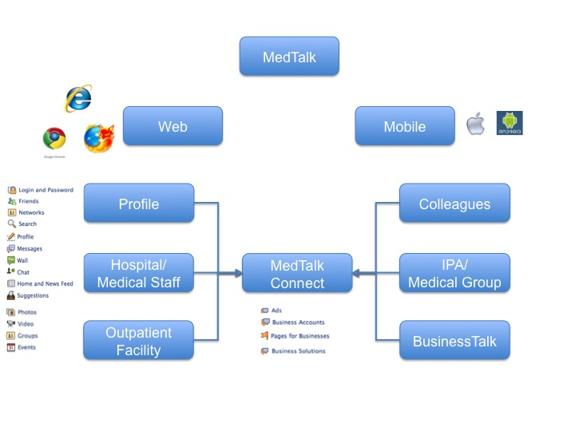

## System Architecture

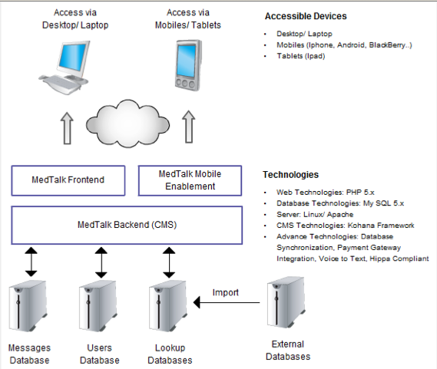

The System Architecture is broken into 4 Layers:

**Extension Layer**

* Allows the system to integrate with third party systems and applications, including social networking sites such as Facebook, Twitter, etc.
* Allow the system to integrate with future modules seamlessly. Integrated modules can be in the form of Drupal extensions (contributed by Drupal Developer Community), third party modules or custom development modules.
* Develop extension modules including: News/ Blogs, Media, Products Catalog, Shopping Cart, Banner Ad, Newsletter, Contact/ Feedback, Site Setting.

**Application Layer**

* Provide the ability to share modules and components within the system. Each module implements specific business rules and tasks which is independent of any integrated modules in the system.
* Shared modules includes: User Management, Component Management, Module Management, Template Management, System Management and Language Management
* Existing modules/ features in the Framework Layer can be customized, and extended to match any requirement.

**Framework Layer**

* Provide the ability to share libraries, API, and services to the Application Layer
* The Framework Layer will be built on .NET CMS Platform

**Database Layer**

* The database layer will use a MySQL database engine which provides greater performance, security, and clustering

Acceptance and authorization

The term of this SOW is from 5/23/2011 to 5/23/2012 assuming that the Buyer approves the final product from the Supplier. Buyer may terminate this SOW upon 15 days written notice.

The terms and conditions of the Professional Services Agreement apply in full to the services and products provided under this Statement of Work.

IN WITNESS WHEREOF, the parties hereto each acting with proper authority have executed this Statement of Work, under seal.

|  |  |  |
| --- | --- | --- |
| David Aguilar/Gil Bender |  | Bruce Watanabe |
| Full name |  | Full name |
| Partner |  | Managing Partner |
| Title |  | Title |
|  |  |  |
| Signature |  | Signature |
|  |  |  |
| Date |  | Date |

# **Appendix**

## Task Breakdown Structure

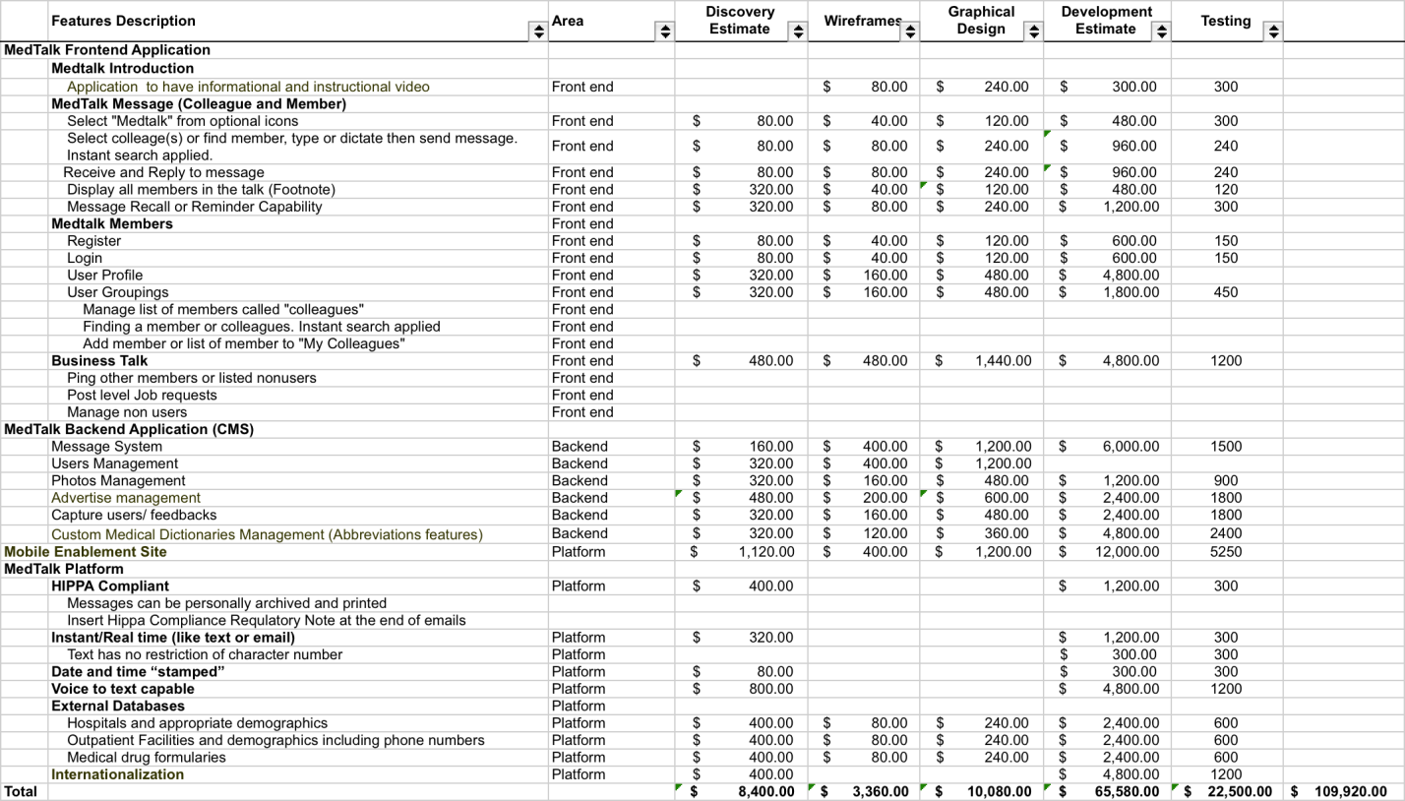

## Misc. Information

**Colleague and Member medtalk**

* log in (after first time, made as easy as possible, e.g. putting in first letter of last name fills in name)
* select “medtalk” from optional icons
* Select colleague(s) or find member, type or dictate then send message, user receives message ***(instant alert)*** and has bubble options to:
  + Thank you and send (default and serves as auto confirm if application closed)
  + Reply and send
  + Not available and send
  + Please contact: and send
  + Not interested and send
  + Not interested block user and send

Make “Colleague” prompt TBD

**Footnote: when multiple members or colleagues are involved with one patient, screen would show all members, the patient (maybe in the center) with all members or colleagues involved surrounding the patient. Members receiving medtalk message will know all members who were or are involved in message. This is different from text messaging whereby a receiving member doesn’t know all of the members just sender.**

**OTHER MEDTALK SPECIFICS**

USERS “MEDTALK MEMBERS”

USER GROUPINGS

PROFILES

OTHER USEFUL DATABASES

FUTURE CONTENT

CAPTURING USERS/FEEDBACK

GENERAL TOPICS

USE CASES

**USERS “MEDTALK MEMBERS”**

Will need to be verified and upgradable as user status changes

Physicians- MDs

Physicians- DOs

* Distinction is made here only to capture all physicians and databases. Medtalk will only refer to physicians not have a distinction between MDs and DOs

Resident Physicians

Medical Students

Nurses

Physician Assistants- PAs

Nurse Practitioners- NPs

Pharmacists

Hospital Personnel or outpatient facility***: initial setup of medtalk to have capability but not include these users.***

* Laboratory technicians
* Radiology technicians

**USER GROUPINGS**

All users will be “medtalk members” each member will have his personal list of members called “colleagues”. Finding a member or colleague would be as fast and simple as possible.

Locating a colleague could happen by either selecting from a list or as in locating a member by searching by name. Typing in letters would bring members up. For example, typing “s” would bring all members, depending on category, with the last name starting with s, further letters would narrow down name. These groupings can be used in addition to search by name in order to:

* Make the network more familiar and comfortable
* Give an option to locate a colleague or member
* Bring the community feeling within groups

Physicians by geographic areas

Physicians by hospital affiliation(s)

Physicians by specialty

Resident Physicians within a residency program (potentially)

Resident Physicians within a hospital program (potentially)

Medical students by medical school

Nurses by Hospital(s) worked at

Nurses by Specialty

Physician Assistants and Nurse Practitioners by specialty worked in

**PROFILES**

Registering, verification of each member and profile set up will be done at the same time. For Physicians, only name and basic verification information (state license number, last 4 of social?) will be required. Other profile information can be optional. Each member will have his personal settings capabilities including colleagues, frequent facilities and telephone numbers used including hospitals, pharmacies labs, xray facilities. Data entry by member might have drop down lists capability.

Physicians Profile (registering will need verification TBD)

* Name (required)
* All other info optional but can be completed at any time:
  + Specialty
  + Address
  + Work telephone
  + Associates within group if not solo
  + Hospital affiliation(s)
  + Medical Group or IPA affiliation(s)
  + Medical School year of graduation

Resident Physicians Profile (registering will need verification TBD)

* Name
* Resident Program
* Level (R-1, R-2, etc…) prompt to change at certain times
* Location
* Specialty

Medical Students Profile (registering will need verification TBD)

* Name
* Medical school class of
* Level (1st-4th year) prompt to change at certain times

Nurses Profile (registering will need verification TBD)

* Name
* Specialty
* Year graduated
* Hospital Affiliation(s)

Physician Assistants and Nurse Practitioners Profile (registering as above TBD)

* Name
* Specialty field
* Address
* Work telephone
* Hospital Affiliation if applicable
* Physician supervisors
* Training program and year of graduation

Pharmacists Profile

* Name
* Specialty (if applicable)
* Facility
* Address
* Work telephone
* Training program and year of graduation

**OTHER USEFUL DATABASES**

These databases would be part of the medtalk application and while the focal point is the “talk” these databases would supplement the application and enhance the member’s experience. They would help the member with their daily work flow. Each database would have personal settings capabilities to make them customizable for each user. When applicable and only if easy: google maps capabilities

* Hospitals and appropriate demographics:
  + Key phone numbers, main, er, admitting. Phone numbers would be dialed if selected.
* Hospital Medical Staff (potentially)
* Outpatient Facilities and demographics including phone numbers:
  + Xray
  + Lab
  + Pharmacies
  + Outpatient surgicenters
* IPA/Medical Groups
  + Primary care Physicians
  + Specialists
  + Medical directors
  + Main telephone number
* Medical drug formularies
  + By specialty if possible
* Useful medical references or textbooks
  + Harrisons, The Red Book, others (potentially)

**FUTURE CONTENT**

Build with initial product, roll out 6 months later

* BUSINESS TALK
  + A feature whereby a user could ping other members or listed nonusers re various aspects involving the business of medicine:
    - Contracting
    - EMR reference physicians
    - Legal
    - Career opportunities
    - Office issues: supplies, devices or anything to do with the office
  + A member could post level job requests to certain geographic areas. The requests would not be part of the talk, not be instant perhaps seen only by the recipient member when they want.

**CAPTURING USERS/FEEDBACK**

Application will capture User groups within categories and have capability to send welcome emails or monthly medtalk messages.

* Messages could be informational
* Welcome email after sign up to be concise, describe uses with brief instruction and include video link tutorial
* Remind of security (brief hippa compliance explanation)
* Tutorial in nature (tutorial icon on main page)
* Notify periodically of similar members by geographic location, hospital staff and specialty.
* Announce new hospital affiliations
* Identify Users activity and send message to those not using
* Will not be intrusive
* Will not solicit or advertise
* Ask for feedback (soft icon)
* Can inform of new features
* Standard helpful hints on medtalk uses can be turned on or off
* Users could send invites to non users with video link, invite would be platform specific, i.e. if viewed on desktop or phone, end user would get the correct platform.
* Nonusers will be captured by invitation email that includes video link

**GENERAL TOPICS**

* Application to have informational and instructional video
* Each video, professional, smooth easy and inviting
* Application will have premium (pay for use) functionality
* Our own emails to have medtalk logo that launches to website or mobile app when selected
* Ability to track unprofessional use and remove users
* Ability for users to report unprofessional use
* Premiums
  + Premiums (hospitals) waived at the beginning then implemented at a designated time frame
* Ability to add advertising when ready with variable premiums depending on targets
* Medical legal disclaimers
* Professional disclaimers

**USE CASES not in order of importance**

1. Physician to medtalk member
   1. Hospitalist(s**) (*a hospitalist is a physician who works primarily in the hospital and takes care of hospitalized patients. In the past each physician would take care of his own patients when they were hospitalized…now dedicated hospitalists do this work and the pcps mostly care for patients in the outpatient or clinic setting)*** selects primary care physician can update status of patient, can notify of hospital course of patient and discharge plans including things like pertinent labs done, tests performed, medications changed or continued.
   2. Hospitalist(s) notifies various physician specialists who are also involved in the care of the patient of the hospital course and or discharge plans.
   3. Hospitalists notify medical directors of IPAs or medical groups above information.
   4. Hospitalist notifies discharge planning nurse or home health nurse of discharge plans.
   5. Pcp, specialist, hospitalist exchange information and orders with nurses in the hospital.
   6. Emergency room physician notifies pcps, specialists and hospitalists of er status. May be things like test results, medications prescribed and discharge from er plans, or admission to hospital plans.
   7. ER physician notifies medical directors of above information---perhaps at the same time when notifying pcps.
   8. Pcp notifies specialist in the office setting of change in management of mutual patient.
   9. Pcp notifies specialist of new pending consult…a heads up and concern.
   10. Specialists in the outpatient clinic setting notify pcps, other specialists of consult findings and future plans.
   11. Surgical specialists notify pcp or other specialists of surgical findings right after surgery.
   12. Pcps and specialists interact, ask and notify medical directors of clinical status and requests for certain management issues.
   13. Medical directors interact with pcps specialists requesting additional information regarding patient management and plans.
   14. Physician could find specialist or other physician at certain tertiary facility and ask clinical advice or administrative question.
2. Resident Physician and or Medical student to medtalk member
   1. Notify pcp, specialist other members of the hospital resident team of patient status
3. **Nurses to medtalk member**
   1. **Hospital nurses notify pcps, hospitalists and specialists of test results, patient status changes, medication requests or changes and request response or order**.
4. Physician Assistants and Nurse practitioners are now functioning as physicians in many settings including the office, the hospital, the emergency room , surgery and anesthesia. All interactions above could occur with these health care providers.